|  |  |
| --- | --- |
| **Experiment Number** | **3** |
| **Date of Experiment** |  |
| **Date of Submission** |  |
| **Name** |  |
| **Roll Number** |  |
| **Section** | ECS-01 |

**Aim of The Experiment :-**

Overview of LabVIEW for signal processing and design & determination of frequency, amplitude and phase of various types of signals using LabVIEW

.

**Equipment and Software Required:-**

The Equipment and Software required are as follows:

LabVIEW

**Block diagram:**

Numeric operations to two input values

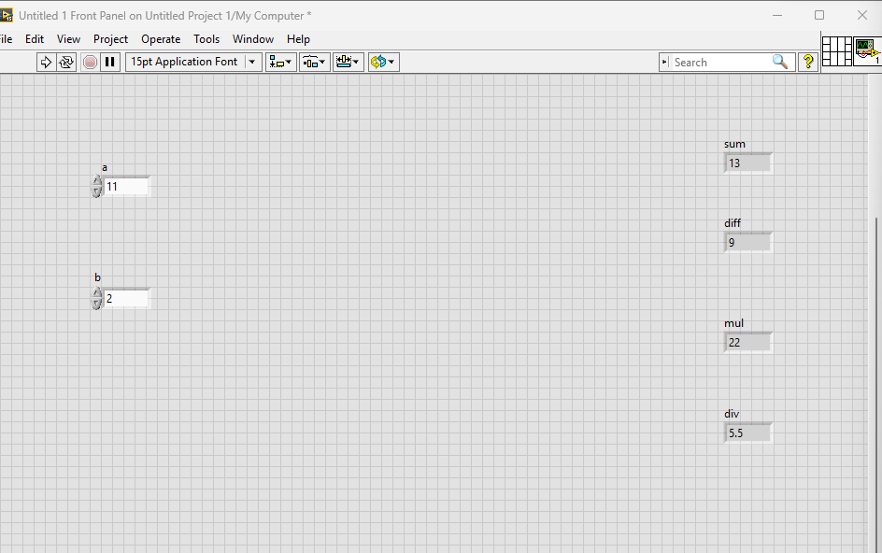

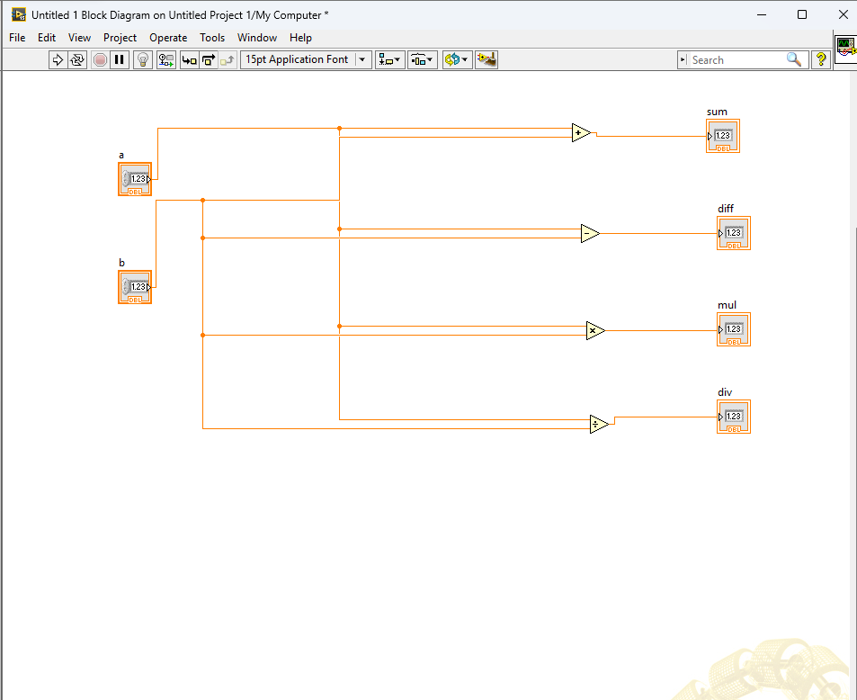

Conversion of Celsius scale to Fahrenheit and vice versa

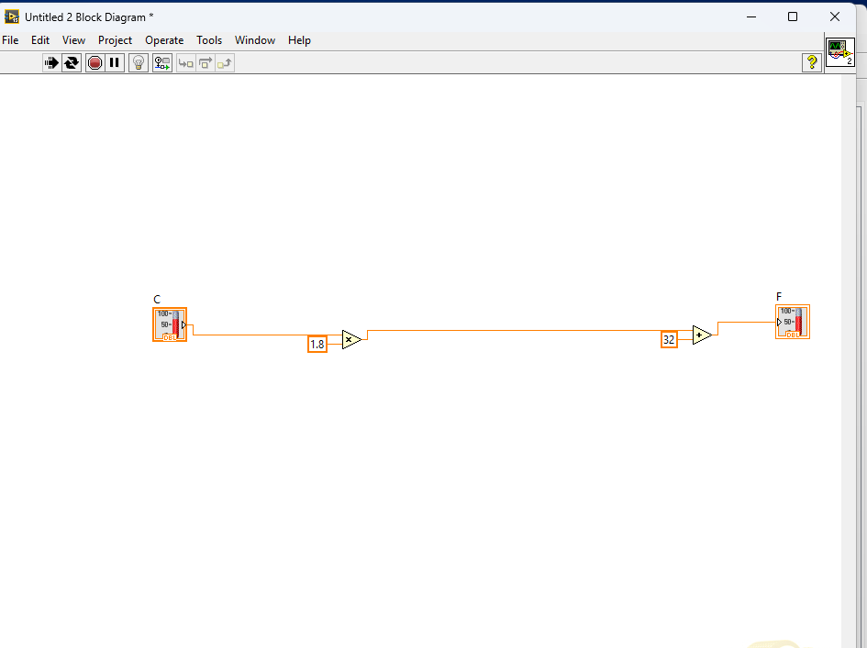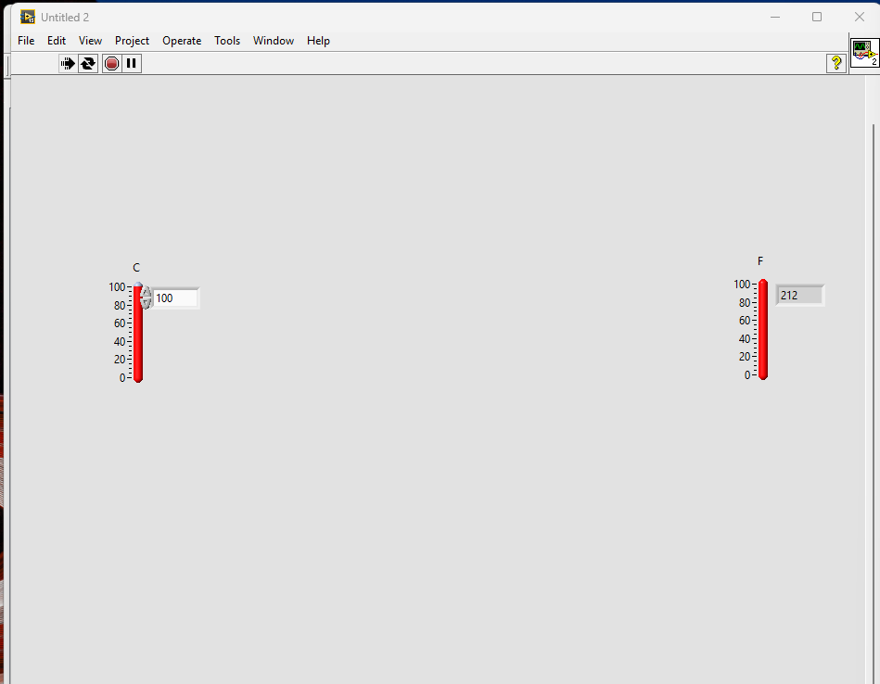

Formation of sine ,aquare and triangle waveform using phase amplitude and frequency input

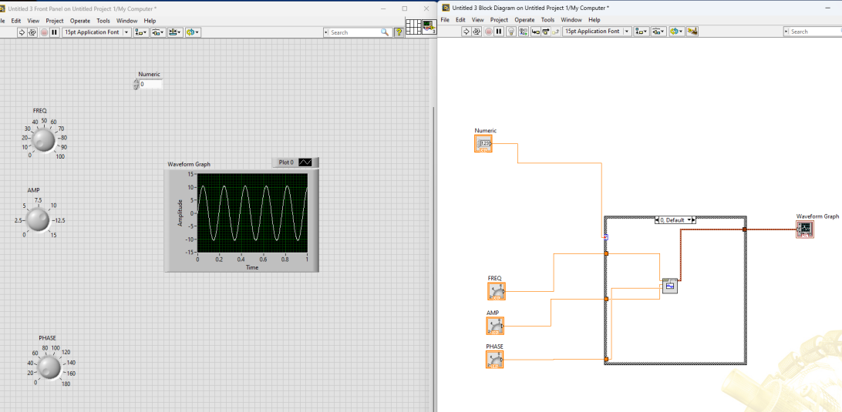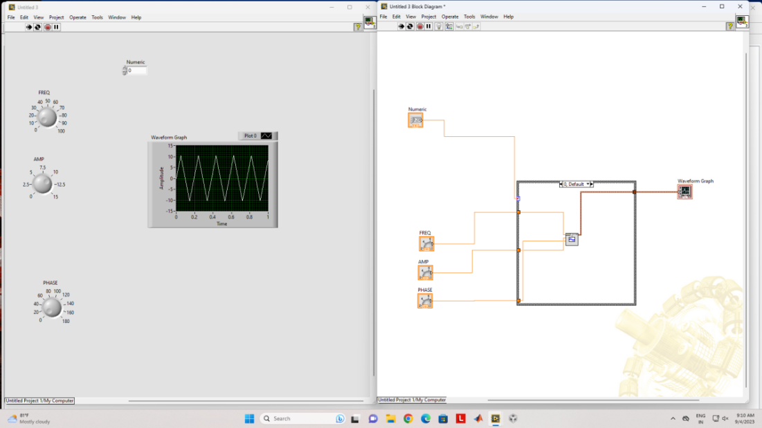

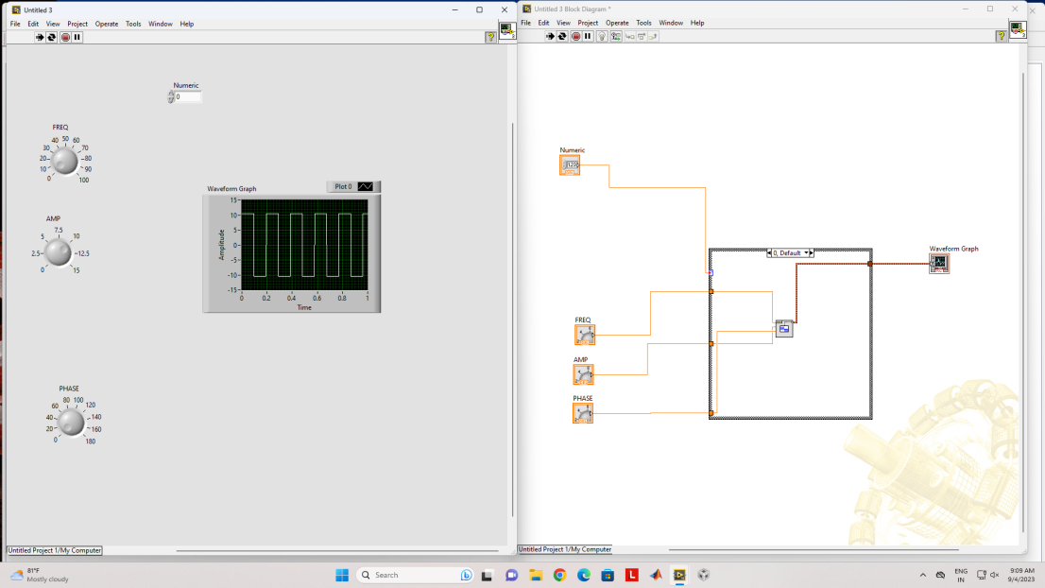

**Discussion or Inference of the experiment:**

Based on this experiment, we created a circuit to perform numerical operations (such as addition, subtraction, multiplication, and division) on two input values. We also used LabVIEW to generate sine, square, and triangle waves by entering values for phase, frequency, and amplitude, and to convert between Celsius and Fahrenheit.

**Conslusion:**

Through this project, we learned how to use LABview to make VIs, generate waveforms, use wiring, use structures, do numeric operations, and provide various inputs (such as by turning knobs and entering values, among other things).